Without a Proper Financing Plan, Let’s Kiss the Education SDG Good Bye
Posted on November 5, 2015 by norrag

https://norrag.wordpress.com/2015/11/05/without-a-proper-financing-plan-lets-kiss-the-education-sdg-good-bye/
By Charles Aheto-Tsegah, National Council for /Curriculum and Assessment, Ghana.
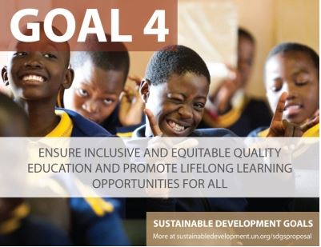Special gratitude to Burnett and Upadhyay for drawing attention to the essential but avoided subject when global targets are being set: the funding arrangement! I have wondered why I am not seeing or hearing about the financing plan that is accompanying the Sustainable Development Goals (SDGs). In hindsight the Millennium Development Goals (MDGs) were situated in a relatively favourable financial context with the pledge by developing partners to set aside resources to help the realization of the targets in low-income and lower-middle-income countries. For education, development partners promised in 2000 that no country seriously committed to Education for All (EFA) would be left behind due to lack of resources. True to this, the Fast track Initiative (FTI), now called the Global Partnership for Education (GPE), was formed. Ultimately, of course, donors failed to fulfil this pledge and it is seen as ‘one of the biggest failures of the EFA period’.
In July this year, heads of state and development and finance ministers from around the world met in Addis Ababa, Ethiopia to discuss financing of all of the new global goals. However, the mood from many civil society organisations was largely pessimistic.
My special concern, however, is the fact that aid to support education, which is a right and an entitlement is dwindling in favour of other issues. The situation suggests that there is a common acceptance that education can always wait because it is not immediately life threatening.
Education Can No Longer Wait!!
Rightly stated innovative financing mechanisms are needed, and in this case especially for education. The time has come to rethink education financing. The World Literacy Foundation recently published an unfortunately unhelpful report on the cost of illiteracy. In my view it did not help make a credible case for the concern. Yet, the fact is that the world will continue to pay heavily for failing to make education a priority. Surprisingly, individually, we accept that education is important and families go to great lengths to ensure that their children are educated, while Governments in developing countries struggle to support low income and poor households to take advantage of new education opportunities and fulfil their part of the global agreement to finance education.
Thinking outside the box concerning the financing of education has become more of a theoretical construct than a realistic effort with sustained effects and outcomes. The process is too dependent on unwilling third parties who are inspired by conditionalities instead of a readiness to assist. They are very quick to make ‘good’ cases for moving funds away from education to some other venture.
Finally, the implementation of a ‘cash on delivery’ funding mechanism will not succeed. As long as we are unable to restructure our results based financing into a system that reduces strain on already struggling economies to show evidence for resources, we shall be heading for a stalemate in education development that portends great disaster for countries and the world. Bluntly put, kiss the SDG4 good bye.
Charles Aheto-Tsegah is the Ag. Executive Director of the National Council for /Curriculum and Assessment in Ghana. Prior to this he held senior positions in the Ghana Education Service, including as Ag. Director-General, Deputy Director-General and Director of the Policy, Budgeting, Monitoring and Evaluation Division. Email: cyatse@gmail.com
>>View all Blogs on the SDGs on NORRAG NEWSBite
Follow this blog by email, Facebook or via Twitter @NORRAG_NEWS
NORRAG (Network for International Policies and Cooperation in Education and Training) is an internationally recognised, multi-stakeholder network which has been seeking to inform, challenge and influence international education and training policies and cooperation for almost 30 years. NORRAG has more than 4,300 registered members worldwide and is free to join. Not a member? Join free here.

